Differential Equations for Black Queen soil simulations

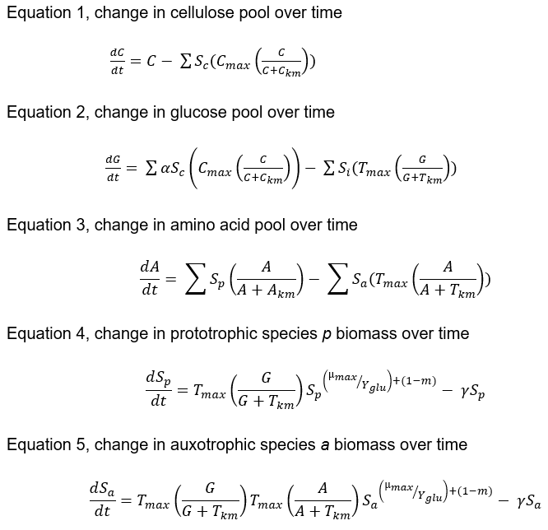

Table 1: Model parameters, symbols and explanations.

|  |  |  |
| --- | --- | --- |
| Parameter | Symbol | Explanation |
| Time (generations) | *t* | Each time point is expressed as a species’ generation. For simplicity, this is the same for all species. |
| Cellulose (µM) | *C* | Cellulose acts as the carbon source for the system, with 2 mM added every 200 generations. |
| Glucose (µM) | *G* | Cellulose must first be catabolised to glucose by cellulase. Glucose is subsequently taken up by species for growth. |
| Cellulase maximum activity and half-saturation constant (per µM) | *Cmax* , *CKm* | Cellulase activity is based on Michaelis-Menten kinetics and performs as the soil bacterium *Bacillus brevis* (Singh and Kumar, 1998). Only cellulytic species produce cellulase. |
| Glucose units per Cellulose | *α* | Glucose yield from one molecule of Cellulose. |
| Amino Acids (nM) | *A* , *AKm* | Amino acids are produced by Prototrophs and secreted as a leaky function based on Monod kinetics. Auxotrophs are dependent on taking up amino acids for growth. |
| Transporter maximum activity and half-saturation constants (per µM) | *Tmax* , *TKm* | Transporters are necessary for uptake of glucose and, in the case of auxotrophs, amino acids. Tmax is consistent between species and is based on *E. coli* phosphotransferase (Ferenci, 1996). TKm differs between copiotrophs and oligotrophs. Oligotrophs have half the Km of copiotrophs, and thus double the affinity for growth substrates. |
| Maximum growth rate and growth yield efficiency on glucose (per µM) | *µmax* , *Yglu* | The maximum growth rate of a species. Oligotrophs have an order of magnitude lower *µmax* than copiotrophs, and thus grow slower. Yglu is based on optimal *E. coli* growth under continuous culture, where 57% of input glucose is converted to biomass (Kayser *et al*., 2005). |
| Maintenance energy | *m* | Maintenance energy is the burden associated with a species’ functional repertoire. The higher the *m*, the slower the overall growth rate. Cellulytic Prototrophs have the highest *m*, followed by Cellulytic Auxotrophs, Non-cellulytic Prototrophs. Non-cellulytic Auxotrophs have the lowest *m*. Oligotrophs also have a slightly higher *m* than copiotrophs due to their higher-affinity, ATP-dependent transporters. |
| Mortality (%) | *γ* | Mortality rate of each species per generation, arbitrarily set to 20%. |
| Species biomass (ng) | *Si* | Increase or decrease in a species’ biomass per generation is a function of the parameters that make up its functional repertoire, life strategy and the capacity for the community as a whole to produce public goods. |
| Cellulytic species biomass (ng) | *Sc* | Those species capable of producing cellulase. |
| Prototrophic species biomass (ng) | *Sp* | Those species capable of producing amino acids. |
| Auxotrophic species biomass (ng) | *Sa* | Those species incapable of producing amino acids. |